**Working Title:**

Factors influencing the health and longevity of created tidal marshes in the Fraser River Estuary, British Columbia

**Authors:**

Daniel Stewart, Daniel Hennigar

**Acknowledgements:**

Ducks Unlimited Canada, funders, VFPA, DFO, MetroVan, UBC Applied Statistics, various private businesses that permitted access, CMN, reviewers (pending)

# Abstract

More than 100 tidal marsh creation projects have been constructed in the Fraser River Estuary, British Columbia, from the 1970s to present. Though these projects share similar habitat creation goals, they differ in their respective designs and environmental contexts. Past studies described and evaluated many of these projects and found varied success, but the factors that determine their outcomes have not yet been formally investigated. Using a combination of field sampling, remote sensing, and statistical modeling, we aimed to address this knowledge gap by asking what factors determine (1) whether created marshes remain vegetated, and (2) the health of created marsh plant communities. We found that recession is an issue among the 79 created marshes visited, with estimated losses of 15,000 m2 of tidal marsh habitat. Protective infrastructure, specifically debris fencing and offshore structures such as marina docks and log storage booms mitigated recession, while sites built in the North Arm averaged 18% more recession. Sites that were lower in elevation and contained higher proportions of edge habitat were more vulnerable to recession than high elevation sites. Dominance of native species declined at a rate of 1% per kilometer upriver, while invasive cattail defied this trend, dominating many of the outer estuary sites it occurred in, with preference for inland basin designs. Native and non-native plant species richness shared similar trends across the estuary, increasing with elevation and distance upriver. These findings offer insight into the role that site design and location play in the outcome of marsh creation projects, and the potential challenges posed by environmental change in the estuary.

# Introduction

Human settlement has occurred in estuaries for millennia as they contain productive airable land, abundant natural resources, and are in close proximity to the ocean (Small & Nichols 2003; Fitzpatrick et al. 2015). The result, particularly in recent centuries as human populations have exponentially increased, has been the escalated alteration, fragmentation, and loss of estuarine habitats around the world. These losses have led to declines in the ecological function, services, and resilience of these ecosystems in an age where threats such as climate change, sea level rise, and species invasions abound (Dahl 1990; Vitousek et al. 1997; Barbier et al. 2011; O’Meara et al. 2017). To this day, habitat loss continues to be one of the major threats to global estuaries, as coastal human populations continue to increase (Kennish 2002).

Estuaries along the Pacific coast of North America have not been immune to these losses. Brophy et al. (2019) estimated that 85% of vegetated tidal wetlands have been lost from estuaries along the contiguous U.S. Pacific Coast, with the greatest losses occurring in major river deltas. The Fraser River delta, the largest estuary on Canada’s Pacific Coast, has seen similar wetland losses, estimated between 70 – 90% since European settlement (Hoos & Packman 1974; Boyle 1997). Such losses are detrimental to the host of species that depend on these habitats, including declining Pacific Salmon populations, who utilize tidal marshes as foraging and refuge habitat during juvenile life stages (Magnusson & Hilborn 2003; Bottom et al. 2005; Chalifour et al. 2019, 2021). The north-south network of estuaries along the west coast also provides critical stopover points for migratory bird species travelling along the Pacific Flyway, and productive foraging, resting, and roosting habitat for waterfowl, shorebirds, songbirds, and gulls (Butler & Campbell 1987; Sutherland et al. 2013).

As awareness around the impacts of human activities in estuaries have increased, so to have efforts to counteract them. In the Fraser River Estuary (FRE), tidal marsh creation projects began in the 1970s but escalated with the introduction of the 1986 *Policy for the Management of Fish Habitat*, which contained guidelines for achieving no net loss (NNL) of the productive capacity of fish habitats in Canada (DFO 1986; Adams & Williams 2004; Bradford et al. 2017). According to the Policy guidelines, unavoidable fish habitat losses[1] would henceforth be balanced by habitat replacement on a project-by-project basis. The primary means of offsetting these losses and achieving NNL was habitat compensation, which depended on the creation of marsh habitats to offset unavoidable losses. Marsh creation projects continue to be proposed and approved in the FRE under the current *Fisheries Act* revisions and Fish Habitat Protection Policy Statement (2019), though now under the broader term of “offsetting” (Bradford et al. 2017; DFO 2019). In this regulatory context over 100 compensatory or offset projects were completed in the FRE from the 1980s to present, representing nearly all attempts at marsh habitat creation in the region to date.

A small number of reports have documented and even evaluated the functioning of these marsh creation projects, each suggesting that success was not universal. Based on created project area, Kistritz (1995) found that a net gain of brackish marsh habitat occurred in the FRE between 1983 – 1992 due to compensation activities; however, follow-up remediation was still recommended at a number of failed sites. Levings and Nishimura (1996) compared the functioning of transplanted, natural (reference) and disrupted (unvegetated) marshes in the FRE and found that the average percent cover of Lyngbye’s sedge (*Carex lyngbyei*) in created tidal marshes sites was < 50% of that observed in reference sites, while transplanted sites had overall higher rush (*Juncus* spp.) cover. Invertebrate abundance was frequently higher in created marshes than reference marshes, and although no differences were found in chinook salmon (*Oncorhynchus tschawytscha*) and chum salmon (*O. keta*) fry among sites, smolt catches were significantly different, with often higher catches at disrupted sites. Adams and Williams (2004) provided a more recent summary of these projects, noting that early marsh-creation efforts were more prone to failure, likely due to poor quality assurance and control during site preparation and planting. Lievesley et al. (2016) attempted to evaluate the success of a subset of these projects, finding that of the 54 marshes visited in their study, 65% achieved their intended vegetated target marsh area, and 50% of sites possessed marsh vegetation comparable in native dominance to neighbouring reference sites.

These reports have described in detail the status of many created marshes, but to our knowledge no research has attempted to formally investigate the mechanisms behind their success or failure. One of the challenges to such an investigation is *defining* project success, as indicated by the wide variety of metrics employed in wetland monitoring programs to date (Adams & Williams 2004; Bradford et al. 2017). Coverage by tidal marsh vegetation is often evaluated as a surrogate for fish habitat quality in estuaries, due to the role of wetland macrophytes in the detrital food web, and in providing refugia for fish (Levings 2004). Marsh vegetation also provides other critical ecological services, including soil stabilisation, water quality maintenance, wave attenuation, carbon sequestration, nutrient cycling and sequestration, and habitat for numerous non-fish species (Peterson et al. 2008; Forysinski 2019).

Metrics that evaluate the composition of a plant community, for example dominance of native versus invasive species, may also be useful in evaluating the function and provisional services of tidal wetlands (ex. Haines & Hanson 1979; Zedler & Kercher 2005). Local studies support this, such as Grout et al. (1997) who found that decomposition rates of invasive purple loosestrife *(Lythrum salicaria*) were significantly faster than native *C. lyngbyei,* with potential implications on the timing of detritus supply and food availability. Lee (2021) and Stewart (2021) found that chironomid abundance and native plant diversity was significantly lower in marshes invaded by non-native cattail (*Typha angustifolia, T. X glauca)* than neighbouring *C. lyngbyei* marshes, suggesting that *Typha* invasions may represent a major disruption to food web interactions and biodiversity in the estuary.

Species diversity is another plant community metric used to assess ecosystem health and resilience. The role of biodiversity in ecosystem stability has been subject to debate (Schwartz et al. 2000), but recent work has demonstrated a stabilizing effect of native species richness on community properties like total above-ground biomass and net-primary production in plant communities, though there was no stabilizing effect on any individual species (Tilman 1996; Tilman et al. 2006; Hector et al. 2010). Native species richness supports community-level stability in at least three ways: (1) variable response to environmental fluctuation among species, (2) variable timing of response and resilience to disturbance events among species, and (3) reduced strength of inter-specific competition (Loreau & de Mazancourt 2013). In a highly dynamic system like the FRE, it is likely that all three of these mechanisms will be critical to the long-term resilience of created marsh communities.

A second obstacle to investigating the mechanisms behind the success or failure of these projects is the multivariate complexity of such an analysis, which requires consideration of both the design, and the contextual uniqueness of a given project. Project designs vary considerably in the FRE from elevated marsh benches, to dike breaches, to excavated inland basins, each differing in size, shape, elevation, age, and degree of protection from debris and erosion. The environmental context of each site is also unique, each being influenced by a unique combination of abiotic (e.g., saltwater influence, tidal influence, erosion) and biotic factors (e.g., herbivory, invasive species), that vary based on location in the FRE.

The objective of this study was to advance our understanding of marsh habitat creation and management in the FRE by learning from the successes and failures of over 40 years of projects. To achieve this, we used a combination of field sampling, remote sensing, and statistical analyses to investigate key factors that contribute to the outcome of projects. Specifically, we asked:

What factors are associated with marsh recession in created tidal marshes?

What factors determine the dominance of native species in created tidal marshes?

What factors are associated with plant community diversity in both created and natural tidal marshes?

# Methods

## Field Sampling

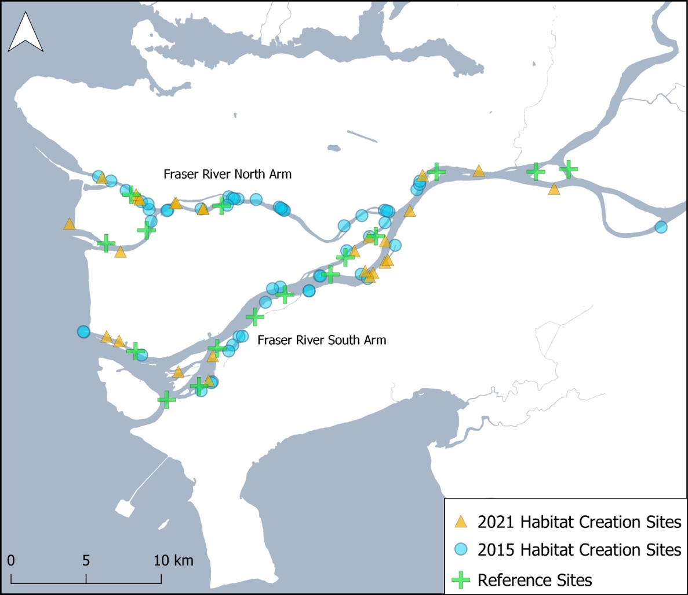This study assessed 79 marsh creation projects and 17 natural reference marshes in the Fraser River Estuary, British Columbia (Fig. 1). This dataset includes 51 tidal marsh creation projects and 7 reference sites surveyed by Lievesley et al. (2016) in 2015, whose work we build upon with an additional 28 created marsh sites and 10 reference sites surveyed in summer 2021. Many of the marsh sampling methods presented here were adapted from Lievesley et al. (2016) to maintain consistency between datasets, thus increasing statistical power for later analyses.

Figure . Map of assessed marsh habitat compensation projects and reference marshes in the Fraser River Estuary (2021: *n* = 38; 2015: *n* = 58; total *n* = 96). Base map: 2016 Canadian Census Boundaries, Statistics Canada.

Created tidal marshes were located using a combination of desk-based and field-based reconnaissance, correlating project descriptions and photographs provided in the BIEAP-FREMP Atlas with field observations and imagery (CMN 2021). Randomized sampling plots were generated in advance of site visits using a random plot generator in QGIS (3.20, QGIS Development Team 2021), with all plots separated by at least 3 m. Not all sites were large enough to contain the target sample size of ~20 plots. In these cases, sample size was reduced. Each plot entailed a 1 x 1 m quadrat oriented perpendicular to the nearest major channel, typically the Fraser River. Surveyors recorded the percent cover of all living macrophytes originating from within the quadrat, as well as exposed substrates (i.e., litter, mud, rock, debris). Percent cover estimates were permitted to exceed 100% in cases where foliar cover of species overlapped significantly. The origin class of each species (native, exotic, invasive, or unknown) was also noted. Plot data were then used to calculate species richness and relative percent cover data for each plot. Relative percent cover is defined as the cover of a given species or grouping of species (e.g., natives) as a percentage of the total plant cover in a plot and was used to account for seasonal bias in our sampling, and high variability of plant forms and densities in our study area.

In addition to vegetation sampling, we mapped the precise boundary of each marsh creation project using a combination of handheld GPS units (Garmin GPS60) and an Apple iPad mini (5th generation) with Avenza Maps mapping software (3.14.1; Avenza Systems Inc. 2021). Vegetated areas, unvegetated mudflats, and log debris accumulations within the intended marsh area were also mapped, to be used in calculations of marsh recession (see 2.2). While mapping the site, we also noted the presence of debris fences, functional foreshore shear booms, and other structures (docks, log storage booms) located immediately offshore.

## Geospatial Data

Geospatial analyses were used to describe the condition and environmental context of plots and sites. Project area was calculated based on polygons mapped in the field and was defined as the marsh boundary of a given project. We calculated the percent of recessed marsh in each project by dividing the area of recessed marsh mapped in the field by the total project area. For the purposes of this study, recessed marsh was defined as areas within created marshes that were primarily absent of vegetation (see Appendix A for photo examples). We calculated percent edge habitat for each site by using the Measurement Tool in QGIS to calculate the area of marsh located within 5 m of the river channel, which we then divided by the project area. Each site was assigned a distance from the river mouth, which was calculated as the channel-distance from each site to a standardized line across the mouth of the Fraser. In cases where multiple pathways to the river mouth were possible, distances were based on those of the largest (and therefore most influential) channel. Elevation data from a publicly available LiDAR dataset was used to calculate both mean site elevation, and sample plot elevation in QGIS (GeoBC, 2021). For each sample plot, proximity to channel was calculated in QGIS using the GRASS Toolbox (7.8.6; GRASS Development Team 2012).

## Statistical Analysis

### Marsh Recession

We used multiple linear regression models in R to determine which factors influence marsh recession in created marshes (lm, ‘stats’ package in R; R Core Team 2021). Percent recessed marsh was used as the dependent variable, and model covariates were selected for their potential relationship to marsh recession based on professional judgement, and data availability. Covariates included descriptive categorical variables, such as presence of a log fence, presence of a shear boom, presence of offshore structures (i.e., log storage booms, dock structures), and river arm. Numeric covariates included project age, project area, distance upriver, percent edge habitat, and mean site elevation. An interaction term was included between mean site elevation and percent edge habitat, as we anticipated that the degree of edge effects on our response variables was highly dependent on project elevation.

### Native Dominance

To determine which factors influence the dominance of native species in created marshes, we modeled the relative % cover/plot of native species using a linear mixed-effects model (‘lmer’, “lme4” package in R; Bates et al. 2015). Sample plot data from created marshes were used for this analysis. Covariates were selected based on data availability, and evidence in the literature of their relevance to plant species distributions in estuaries. Numeric covariates included plot distance upriver (a proxy for saltwater and tidal stress), plot elevation, plot distance to nearest channel, and age of habitat creation site. River arm and inland basin were binary categorical variables. Sample year and sites were included as random effects to account for potential sampling differences between 2015 and 2021 datasets, and to account for site-to-site variation (lmer, ‘lme4’ package in R; Bates et al. 2015). We included an interaction term between both plot distance upriver, and plot channel proximity with elevation, as we anticipated the effect of both covariates to be dependent on elevation.

### Species Richness

We used linear mixed-effects models to investigate factors that influence native and non-native species richness across the estuary (‘lmer’, “lme4” package in R; Bates et al. 2015). These richness models differed from the native dominance model in that they included plot data from both reference sites and created marshes. As a result, model covariates differed in the addition of a binary categorical to distinguish between reference and created marshes, and the removal of site age as a covariate, since the age of reference marshes could not be estimated. An interaction term between plot distance upriver and elevation was included in both richness models, as we expected the effect of plot distance upriver on richness to be dependent on plot elevation.

All models were evaluated for collinearity using variance inflation factors (VIF; vif, “car” package in R; Fox & Weisberg 2019). No model variables exceeded our VIF threshold of 5.0, indicating no significant collinearity was present (James et al. 2013). Model assumptions and fit were assessed through data visualizations, including residual plots to ensure no obvious patterns were present, quantile-quantile (QQ) plots to ensure approximate normality. Fit was also evaluated using adjusted R2 values for the linear marsh recession model, which evaluates the degree to which a response variable is explained by the model while also accounting for the number of independent variables, and R2 values for the linear mixed effects models were reported using methods described by Nakagawa and Schielzeth (2013) using the “MuMIn” package in R (r.squaredGLMM; Bartoń 2020). All statistical analyses were performed using R version 4.0 (R Core Team 2021).

# Results

## Marsh Recession

Recessed marsh ranged from 0–100% across the 79 created tidal marshes, averaging 11.0 +/- 21.0.% σ. This equates to approximately 15,000 m2 of recessed created tidal marsh in our study area. Three sites (3%) were entirely unvegetated mudflat, while 58 (61%) had no observable recession. Sites varied considerably in their numeric variable ranges: distance upriver (0.4–46.9 km), age (6 –43 years), size (20 –59,000 m2), mean elevation (-0.41–2.16 m) and proportion of edge habitat (0.0 –36.4%; Fig. 2).

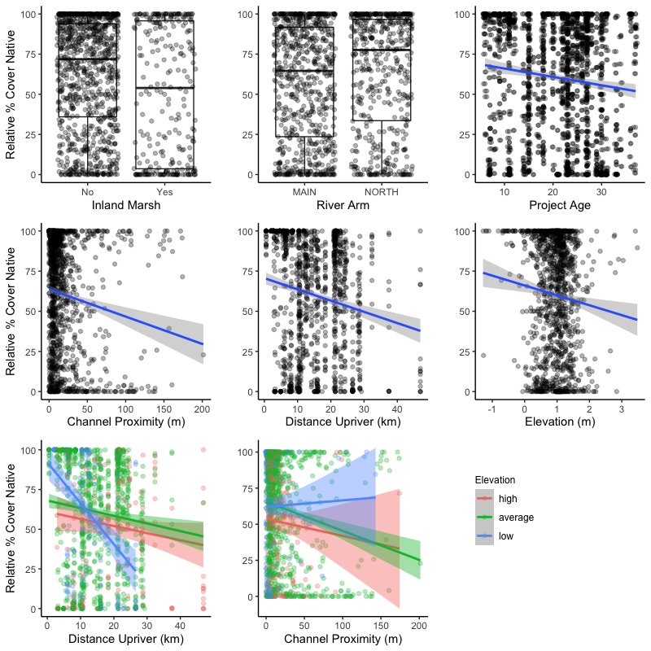

Figure 2. Scatter plots and box and whisker plots displaying the distribution of data for each covariate used in the marsh recession model. Box and whisker median values are shown by the middle horizontal line of each box plot, separating the upper box (2nd quartile) and lower box (3rd quartile) Mean elevation and % edge habitat were entered as interacting terms, which we have visualized by showing the interactions relative to low (< [mean - σ]), average (mean), and high (> [mean + σ]) maximum elevation values (centre bottom).

Results from our linear regression model indicate that sites with protective infrastructure, such as offshore structures (*p* = .013), and perhaps log fences (*p* = .060), appeared to be more resilient to recession, averaging 13.5% and 26.6% less recessed marsh respectively (*F* (11,67) = 2.709*,* adj. *R2 =* 0.194, *p* = .006; Fig. 3). Conversely, percent recessed marsh was on average 18.9% higher in North Arm than South Arm sites (*p* = .001). Presence of a foreshore shear boom, inland basin designs, site age, and site size had no significant effect on recession. As interacting terms however, mean elevation and percent edge habitat had a significant effect on marsh recession. This significant interaction indicates that recession increases most strongly as percent edge habitat increases in low and average elevation conditions, with diminished effects in higher elevations (Fig. 2).

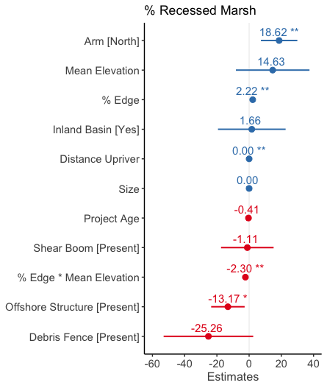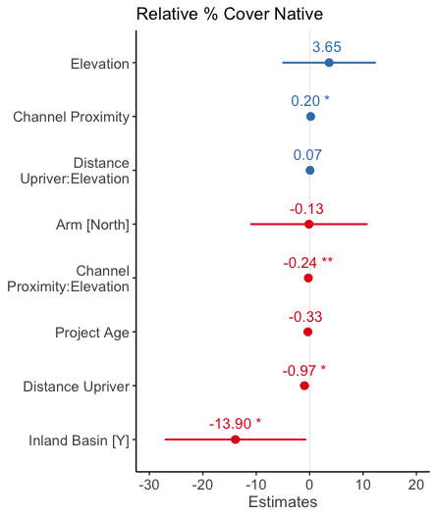

Figure 3. Model coefficients for fixed effects included in percent recessed marsh (left) and relative percent cover native (right) models. Coefficients right of 0 (blue) indicate positive effects, and those located to the left of zero (red), indicate negative effects. Within each panel, coefficients are ordered from the most to least positive effects. Coefficients with statistically significant effects are noted with asterisks (p < .001 ‘***’, .01 ‘**’, .05 ‘*’). Error bars represent 95% confidence intervals.

### Relative % Cover Native Species in Created Marshes

A total of 1282 vegetation plots sampled in created marshes were included in this analysis, with 802 plots sampled at 51 sites in 2015, and 420 plots sampled at 28 sites in 2021 (Fig .4). Sampling effort was similar among years in created marshes, averaging 15.7 plots/site in 2015 and 15.0 in 2021. Relative percent cover of native species ranged from 0–100% in the created marsh sample plots, averaging 60.3 +/- 35.8 σ %.

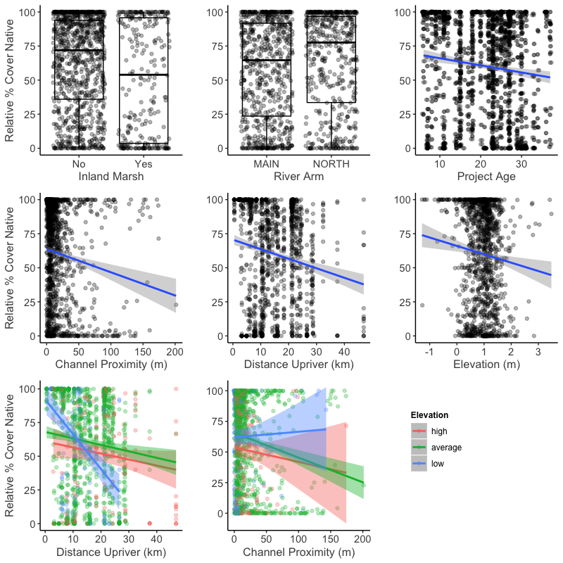

Figure 4. Scatter plots and box and whisker plots displaying the distribution of data for each covariate used to model relative percent cover of native species per plot. Box and whisker median values are shown by the middle horizontal line of each box plot, separating the upper box (2nd quartile) and lower box (3rd quartile) Percent edge habitat and distance upriver were entered as interacting terms with elevation, which we have visualized by showing the interactions relative to low (< [mean - σ]), average (mean), and high (> [mean + σ]) maximum elevation values (centre bottom).

Among model main effects, only channel proximity (*p* = .032) had a significant positive effect on native dominance (marginal *R*2 = 0.069, conditional *R*2= 0.407; Fig. 3). The significant interaction between channel proximity and elevation suggests that mid to high elevation marshes generally experience more significant declines in native dominance with distance from channels (Fig. 4). Distance upriver and plots located in inland basins had more substantial negative effects, with plots averaging declines of nearly 1% per kilometer upriver, and 14% in inland basins. Project age, river arm and elevation had no significant effect. Though no significant interaction was observed between distance upriver and elevation, there are indications that low elevation marshes experience greater declines in native dominance with distance upriver than mid to high elevation marshes.

### Ecosystem Resilience: Species Richness of Marshes in the Fraser Estuary

A total of 1752 sample plots were included in richness models, with 1282 originating from 79 created marshes, and 470 from 16 reference marshes (Fig. 5). Sampling effort was similar in compensation sites between years (see 3.1.1), however reference sites were sampled with greater intensity in 2015, averaging 42.0 plots/site versus 19.8 plots/site in 2021. Native richness ranged from 0 - 13 species/plot, averaging 3.6 +/- 2.3 σ. Elevation (*p* <.001), distance upriver (*p =* .028), and channel proximity had significant positive effects on native richness, with an average increase of 0.8 native species/plot with each meter elevation, .06 native species/plot with each kilometer upriver, and .01 species/plot per meter distance from channel (marginal *R2*= 0.641, conditional *R*2= 0.444; Fig. 6). The placement of a plot in a reference site had no significant effect, nor did river arm or an interaction between distance upriver and elevation.

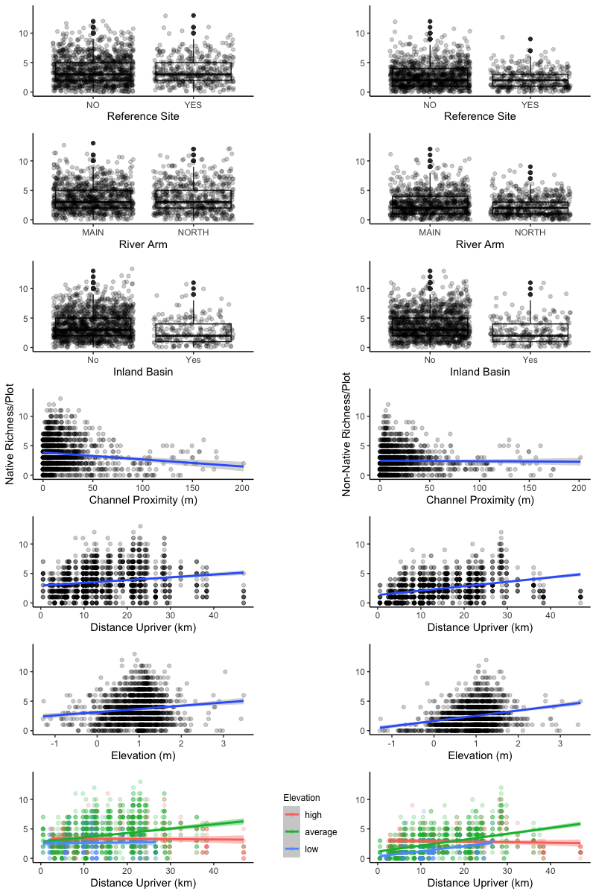

Figure 5. Scatter plots and box and whisker plots displaying the distribution of data for each covariate used to model native richness/plot (left) and non-native richness/plot (right). Box and whisker median values are shown by the middle horizontal line of each box plot, separating the upper box (2nd quartile) and lower box (3rd quartile) Percent edge habitat and distance upriver were entered as interacting terms with elevation, which we have visualized by showing the interactions relative to low (< [mean - σ]), average (mean), and high (> [mean + σ]) maximum elevation values (centre bottom).

Non-native richness ranged from 0 – 12 species/plot, averaging 2.4 +/- 1.9 σ over the study area. Similar to native richness, non-native richness was correlated with elevation (*p* < .001), distance upriver (*p* <.001), and proximity to channel (*p* = .007; marginal *R*2 = 0.164 conditional *R*2 = 0.522; Fig. 6). The placement of plots in inland basins, the North Arm or in reference sites had no significant effect on non-native richness, though there are indications that plots in reference sites may be prone to lower non-native richness than those of created marshes (*p* = .084). A significant interaction was found between distance upriver and elevation (*p* = .002), indicating that the effects of distance upriver on non-native diversity is dependent on elevation. Average and low elevation marshes appear to increase in richness with distance upriver, whereas high elevation marshes experience minimal change. Though not statistically significant, similar trends were observed with the native richness model (see Fig. 5 for all visualized interactions).

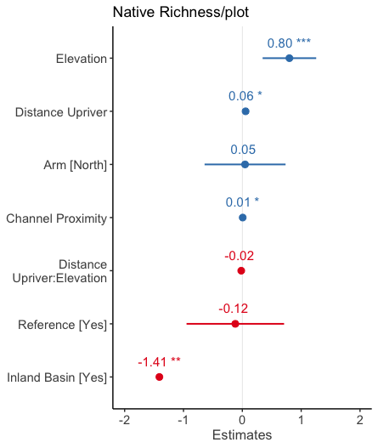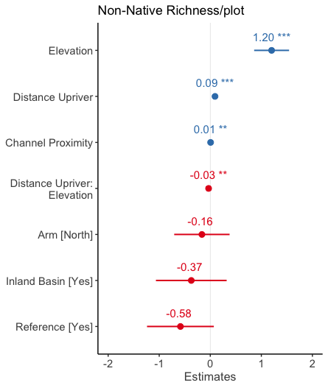

Figure 6. Model coefficients for fixed effects included in native richness (left) and non-native richness (right) models. Coefficients right of 0 (blue) indicate positive effects, and those located to the left of zero (red), indicate negative effects. Within each panel, coefficients are ordered from the most to least positive effects. Coefficients with statistically significant effects are noted with asterisks (p < .001 ‘***’, .01 ‘**’, .05 ‘*’). Error bars represent 95% confidence intervals.

# Discussion

## Marsh Recession Mitigation Strategies

We found that marsh recession is frequent in created marshes of the FRE, occurring in 39% of projects included in this study, and representing about 15,000 m2 of total habitat. Similar to recession occurring in the natural marshes of the outer estuary, isolating a lone driver for these losses is unlikely, as there are likely several contributing and interacting factors leading to plant mortality (Balke 2017; Marijnissen & Stefan 2017). Wave erosion, herbivory by Canada Geese *(Branta canadensis*)*,* altered sediment processes, sea level rise, and shading by bridge structures or neighbouring riparian vegetation are all possible causes, and warrant further investigation.

Offshore structures, which included log storage booms and dock structures, were negatively correlated with recession, suggesting they are at least partially mitigating the biotic and/or abiotic drivers of marsh loss. Considering that log storage booms are often installed to reduce the energy of boat wake (Adams & Williams 2004), this may indicate that boat wake is a significant driver of recession. Further evidence of wake impacts may be in the difference between Main Arm and North Arm sites, with North Arm sites averaging 18% more recessed area per site. Though both river arms support substantial boat traffic, the North Arm channel is narrower throughout, allowing less time and distance for wave energy to dissipate before reaching the shore.

The negative effect of debris fences on recession may also be interpreted as evidence of wave erosion, as these fences generally occur at the entrance to highly protected inland channels and lagoons. But this may also suggest that Canada Geese are a factor behind recession. Canada Geese have already been attributed to planting mortality and failure in several tidal marshes in the FRE (Kistritz 1995; Adams & Williams 2004), and sedge marsh losses in nearby estuaries (Crandell 2001; Dawe et al. 2015). Herbivory was noted in more than half of the created marshes visited in this study, with high (community altering) impacts observed in 14%, moderate (widespread clipping) in 15%, and low (occasional clipping) in 24% of sites, suggesting that herbivory impacts are prevalent in the estuary (Fig. 7). Inland marsh designs may offer a solution to herbivory, as sites are generally less accessible to Canada Geese, who rely on tidal flats and large channels to enter marshes, and generally avoid enclosed areas where tall vegetation or human structures obscure their vision. Our data support this hypothesis, as 9 out of 13 (69 %) of inland sites visited in our surveys had no visible sign of herbivory and none were graded as moderate or high intensity. Maximum *C. lyngbyei* leaf height data from vegetation plots also appear to be slightly higher in inland sites than those exposed to river channels (Fig. 7)

Figure 7. Bar plot (left) showing the number of created marsh sites (inland versus non-inland) per grazing intensity class, based on field notes and photos taken in 2015 by Lievesley at al. (2016) and this study (2021) Classes were defined as “None” (no evidence of herbivory), “Low” (occasional clipped plants), “Moderate” (widespread clipping), and “High” (community altering). Boxplot (right) showing the maximum Lyngbye’s sedge height per plot in inland sites versus non-inland created marshes.

Somewhat counter-intuitively, we found that project size was not negatively correlated with marsh recession, suggesting that project size does not equate to recession resilience. This finding runs contrary to the prevailing opinion that larger projects are more resilient to external stressors due to their size. Instead, we found that proportion of edge habitat had greater influence, and was positively correlated with recession, particularly in low to mid elevation marshes. These findings do not disqualify large-scale projects, as large projects have higher potential for reducing edge effects and possess many other values but highlights the need for incorporating edge effects into project designs.

## Edge Effects & Sea Level Rise

Low and mid-elevation created marshes with a large percentage of edge habitat experienced more marsh recession than high marshes, indicating that elevation is linked to the intensity of edge effects. This is of particular concern in a coastal context where sea levels are estimated to increase by up to two meters by the year 2200 (Ausenco Sandwell 2011). Increases in ocean heights may amplify edge effects by exposing marshes to wake and river flow energy for longer durations, increasing grazing access by Canada Geese, and plant community resilience through increased inundation and salinity stress.

Low elevation was also correlated with significantly lower native and non-native species richness, a pattern common to estuaries around the world (Engels & Jensen 2009). Native species richness plays an important role in stabilizing the community-level effects of environmental fluctuations (Loreau & de Mazancourt 2013), and may be critical for the persistence of tidal marshes in the context of large-scale environmental change. There was no observed difference in native or non-native species richness between created marshes and reference marshes, indicating they are similarly equipped for environmental change. However, the pattern of low richness at the margins of tidal marshes could be problematic, as the pool of species, and therefore diversity of morphological and functional traits facing these environmental extremes, is minimal. We recommend that experiments be conducted on these specialists to further quantify their resilience to change. Experimental translocation of native species within the estuary may also be considered, as the current distribution of native species is likely not indicative of what is best adapted to future conditions.

Coastal squeeze is a term used to describe the loss of intertidal habitat due to the low water mark migrating landward due to sea level rise, while the high water mark is fixed by a dike or other defence infrastructure (Loreau & de Mazancourt 2013). We propose another form of coastal squeeze may also occur, as rising sea levels force the retreat of native marsh communities into high elevations dominated by established invasive species (Fig. 8). This is evidenced by our richness data. First, the distribution of our richness data, though positively correlated with elevation, appears to be symmetric and unimodal, peaking around 1 m elevation (Fig. 5). This suggests that the species-rich elevations of the estuary are currently constrained by environmental stress at low elevations, and another, unknown factor in upper elevations. Second, we found that richness generally increased with distance upriver, but this trend was not observed in high elevations, which appear to remain stable throughout the estuary. Though only observational, we believe that reed canarygrass (*Phalaris arundinacea*) is likely this biotic barrier, as (1) we have observed it as a dominant species throughout the estuary, particularly in mid to high elevation marshes where salinity and tidal stresses are minimal, (2) only it and invasive cattail are known to form dense monocultures among the four invasives of the region (Fig. 9), and (3) it may be better-adapted to higher elevations because unlike the other invasives, it is not an obligate wetland species (Lichvar et al. 2012), and can be found in upland and disturbed environments. For this biotic form of coastal squeeze to be realized, *P. arundinacea* would need to be resilient native species encroachment in the face of environmental change. This is yet to be confirmed, and warrants further investigation.

Figure 8. Illustration of the biotic coastal squeeze proposed by the authors. Reed canarygrass is present in many of the high marshes of the Fraser Estuary (A) and is likely resilient to environmental change once established. As rising sea levels force the retreat of native marshes, their low competitive ability, and inability to move upslope may lead to their disappearance (B).

## Invasive Species

Relative percent cover of native species decreased at a rate of about 1% per km upstream, a trend that correlates with the percent frequency per site data of invasive plants in our surveys (Fig. 9). The high invasion resilience of marshes near the delta front can likely be attributed to elevated salinity and tidal stress, which exclude most competitors and facilitate the dominance of a small number of native specialists, such as common threesquare bulrush (*Schoenoplectus pungens*)and Lyngbye’s sedge. As conditions become more favourable upstream, the pool of native and non-native species competing for marsh habitats increases, as evidenced by the positive effect of distance upriver on richness in our models, likely resulting in the diminished dominance of natives. These results align with Crain et al. (2004) who found through transplant experiments that dominant saltwater specialist diminished in competition experiments as salt stress was reduced, succumbing to more competitive freshwater wetland species.

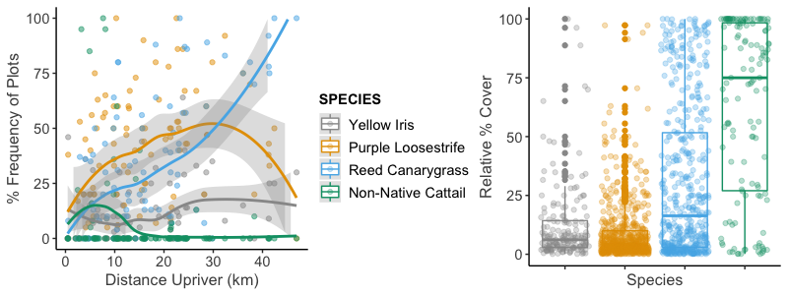

Figure 9. Scatterplot showing the % frequency of plots of four known invasive species in the Fraser Estuary with increasing distance upriver (left) and the relative percent cover of those species, when present in a plot (right). Data were collected from created and reference marshes in the FRE by Lievesley et al. (2016) and in 2021. Loess regression lines display non-parametric trends in the data.

Invasive species that can defy these specialist-competitor interactions and successfully establish in the delta front should be of concern to managers, as they may be able to exploit the low competitive ability of sympatric natives. In the FRE, invasives that are most successful along the delta front are English cordgrass (*Spartina anglica*), which is not present in any of the sites included in this study, and non-native cattail, which differs from the other estuarine invasives in being primarily restricted to the lower 10 km of the estuary, and only 15 sites (Fig. 9; Stewart, 2021). Conversely, yellow flag iris (*Iris pseudacorus*), purple loosestrife, and reed canarygrass (*Phalaris arundinacea*) were found throughout the study area in 42, 66 and 56 sites respectively. Though native dominance was generally highest near the estuary mouth, cattail-invaded sites were often outliers, with low native dominance. This may be attributed to the high displacement ability of cattail, as well as the low competitive ability of sympatric species, as plots containing cattail averaged a relative % cover of 68.8 +/- 37.2 % σ, significantly higher than any other invasive species (Fig. 9).

This trend of declining native dominance with distance upriver may be useful for managers and practitioners as they plan for invasive species in the design and maintenance of created tidal marshes. Sites constructed further upriver may require more intensive and long-term invasive species management, as they appear more vulnerable to invasion. Near the estuary mouth, managers may need to shift their attention towards non-native cattail. Stewart (2021) found that created tidal marshes in the FRE were more proportionally invaded and vulnerable to invasion than natural marshes, and suggested that design, including factors such as elevation, proximity to neighbouring infestations, and connectivity to the Fraser River may be factors. Our findings support this, as the 15 created marshes where cattail is present, 9 (60%) are inland designs, representing 69% of all inland sites in this study. Not surprisingly, inland sites were negatively correlated with native dominance, averaging 14% less native relative perecent cover than non-inland sites. Managers and practitioners must therefore balance the benefits of inland site designs (as discussed in 4.1) with their potential vulnerability to cattail and other species invasions.

## Monitoring Implications

Contrary to our expectations, the age of created marshes did not have a significant effect on marsh recession, nor on relative percent cover of native species. This indicates that (1) well-designed and implemented tidal marsh creation projects, particularly those that account for threats such as invasive species, wake erosion and goose herbivory, may be resilient in the long term, and (2) the success trajectory of a project should be evident not long after it is completed. Site age was not included in our richness models, as we included data from natural marshes that had no defined age. However, our reference site covariate operated as a proxy for age to a degree, as reference sites are inherently much older than created sites. Since no significant difference was observed in native and non-native richness between reference and created tidal marshes, it appears that created marshes can resemble natural marshes in their species composition and vegetation health in a relatively short amount of time, either through natural colonisation, or through propagules introduced via transplant cores from neighbouring natural marshes. Together, these findings suggest that the five-year monitoring requirements of many of these projects may have been sufficient to predict their long-term outcome.

## Data limitations and Underlying Mechanisms

While these findings and interpretations provide valuable decision-making tools for restoration practitioners, there are key data limitations to consider. The covariates included in these models point to important trends in marsh recession and vegetation health, but they do not identify the mechanisms underlying these phenomena. Further study will be required to identify the precise nature of these mechanisms, and to determine how best to mitigate them. Our findings indicate that wave action mitigating structures are correlated with reduced marsh recession, but further study should investigate the direct effects of wake erosion on marsh health, and the most reliable and cost-effective techniques to mitigate wake impacts. Likewise, further research is needed to identify the distribution and magnitude of goose herbivory impacts and to develop effective goose management strategies.

None of our models exceeded *R*2 = 0.6, indicating that there are likely several biotic and abiotic factors that were not included as covariates, but which could have improved model performance and accounted for much of the variation in our data. Examples of abiotic factors include true measures of salinity and tidal prism (not inferred from distance upriver), direct measurements of wave energy impacting the created marshes, and site-level edaphic data to ascertain soil qualities. Design and implementation factors also suffered from data deficiency and incomplete records. Ideally, project design factors like planting prescriptions, geese mitigation, monitoring plans, and maintenance plans would have been included, as well as overall project cost. Our models provide useful insights, but further investigation into the successes and failures of marsh creation in the FRE is warranted.

# Conclusion

Assessments of the more than 100 marsh creation projects in the Fraser River Estuary have heretofore been restricted to qualifying success or failure. Here we sought to identify what factors determine marsh creation success through field sampling, remote sensing, and rigorous statistical models. We found that approximately 15,000 m2 of marsh recession has occurred in created marshes of the FRE, which we found to be negatively correlated with shoreline protecting structures like shear booms and offshore floating structures like log storage booms. Our findings point to wake erosion and goose herbivory as potential underlying causes of marsh recession, though further investigation into these mechanisms is warranted. Marsh recession, relative cover of native species, and native species richness were all influenced by edge effects and elevation, an important finding as sea level is projected to rise in our region. We hope that lessons from these investigations will contribute to more successful marsh creation projects and inspire further study of the underlying causes of marsh creation success and failure.

# Works Cited

Adams MA, Williams GL. 2004. Tidal marshes of the Fraser River estuary: composition, structure, and a history of marsh creation efforts to 1997. Pages 147–172 in Groulx DC, Luternauer JL, Bilderback DE, editors. Fraser River Delta, British Columbia: Issues of an Urban Estuary. Available from https://geoscan.nrcan.gc.ca/starweb/geoscan/servlet.starweb?path=geoscan/fulle.web&search1=R=215772 (accessed September 7, 2021).

Ausenco Sandwell. 2011. Climate Change Adaption Guidelines for Sea Dikes and Coastal Flood Hazard Land Use. Page 59. BC Ministry of Environment. Available from https://www2.gov.bc.ca/assets/gov/environment/air-land-water/water/integrated-flood-hazard-mgmt/sea_dike_guidelines.pdf.

Avenza Systems Inc. 2021. Avenza Maps. Toronto, Ontario.

Balke E. 2017. Investigating the role of elevated salinity in the recession of a large brackish marsh in the Fraser River estuary. Masters Project. Simon Fraser University & British Columbia Institute of Technology, Burnaby.

Barbier EB, Hacker SD, Kennedy C, Koch EW, Stier AC, Silliman BR. 2011. The value of estuarine and coastal ecosystem services. Ecological Monographs **81**:169–193.

Bartoń K. 2020. MuMIn: Multi-Model Inference. Available from https://CRAN.R-project.org/package=MuMIn.

Bates D, Mächler M, Bolker B, Walker S. 2015. Fitting Linear Mixed-Effects Models Using **lme4**. Journal of Statistical Software **67**. Available from http://www.jstatsoft.org/v67/i01/ (accessed September 7, 2021).

Bottom DL, Simenstad CA, Burke J, Baptista AM, Jay DA. 2005. Salmon at river’s end: the role of the estuary in the decline and recovery of Columbia River salmon. Page 246. NOAA Tech. Memo NMFS-NWFSC-68. U.S. Dept. Commer. Available from https://pdxscholar.library.pdx.edu/cgi/viewcontent.cgi?article=1023&context=cengin_fac (accessed October 20, 2021).

Boyle CA. 1997. Changes in Land Cover and Subsequent Effects on Lower Fraser Basin Ecosystems from 1827 to 1990. Environmental Management **21**:185–196.

Bradford MJ, Macdonald JS, Levings CD. 2017. Monitoring fish habitat compensation in the Pacific region: lessons from the past 30 years. Page vi + 26. 2017/033, DFO Can. Sci. Advis. Sec. Res. Doc. Fisheries and Oceans Canada, Ottawa.

Breheny P, Burchett W. 2017. Visualization of Regression Models Using visreg. The R Journal **9**:56–71.

Brophy LS, Greene CM, Hare VC, Holycross B, Lanier A, Heady WN, O’Connor K, Imaki H, Haddad T, Dana R. 2019. Insights into estuary habitat loss in the western United States using a new method for mapping maximum extent of tidal wetlands. PLOS ONE **14**:e0218558.

Butler RW, Campbell RW. 1987. The Birds of the Fraser River Delta: Populations, Ecology and International Significance. Occasional Paper **65**:1–73.

Chalifour L, Scott DC, MacDuffee M, Iacarella JC, Martin TG, Baum JK. 2019. Habitat use by juvenile salmon, other migratory fish, and resident fish species underscores the importance of estuarine habitat mosaics. Marine Ecology Progress Series **625**:145–162.

Chalifour L, Scott DC, MacDuffee M, Stark S, Dower JF, Beacham TD, Martin TG, Baum JK. 2021. Chinook salmon exhibit long-term rearing and early marine growth in the Fraser River, British Columbia, a large urban estuary. Canadian Journal of Fisheries and Aquatic Sciences **78**:539–550.

Community Mapping Network (CMN). 2021. BIEAP - FREMP Atlas. Available from https://cmnmaps.ca/dfo_fremp/ (accessed November 22, 2021).

Crain CM, Silliman BR, Bertness SL, Bertness MD. 2004. Physical and Biotic Drivers of Plant Distribution Across Estuarine Salinity Gradients. Ecology **85**:2539–2549.

Crandell CJ. 2001. Effect of grazing by Branta canadensis (Canada Geese) on the fitness of Carex lyngbyei (Lyngby’s sedge) at a restored wetland in the Duwamish River Estuary. Masters Thesis. University of Washington, Seattle, WA.

Dahl TE. 1990. Wetlands losses in the United States 1780s to 1980s. Page 13. U.S. Department of the Interior, Fish and Wildlife Research. Available from https://www.fws.gov/wetlands/documents/Wetlands-Losses-in-the-United-States-1780s-to-1980s.pdf (accessed October 19, 2021).

Dawe NK, Boyd WS, Martin T, Anderson S, Wright M. 2015. Significant marsh primary production is being lost from the Campbell River estuary: another case of too many resident Canada Geese (Branta canadensis)? **25**:11.

Department of Fisheries and Oceans. 1986. Policy for the management of fish habitat. Pages 1–32. Communications Directorate, Ottawa, Ontario.

Engels JG, Jensen K. 2009. Patterns of wetland plant diversity along estuarine stress gradients of the Elbe (Germany) and Connecticut (USA) Rivers. Plant Ecology & Diversity **2**:301–311.

Fisheries and Oceans Canada. 2019. Fish and Fish Habitat Protection Policy Statement. Page 37. Ottawa.

Fitzpatrick SM, Rick TC, Erlandson JM. 2015. Recent Progress, Trends, and Developments in Island and Coastal Archaeology. The Journal of Island and Coastal Archaeology **10**:3–27.

Forysinski K. 2019. Nature-based flood protection: the contribution of tidal marsh vegetation to wave attenuation at Sturgeon Bank. Masters Thesis. University of British Columbia.

Fox J, Weisberg S. 2019. An {R} Companion to Applied RegressionThird. Sage, Thousand Oaks, California. Available from URL: https://socialsciences.mcmaster.ca/jfox/Books/Companion/.

GRASS Development Team. 2012. Geographic Resources Analysis Support System (GRASS). Open Source Geospatial Foundation. Available from http://grass.osgeo.org.

Grout JA, Levings CD, Richardson JS. 1997. Decomposition Rates of Purple Loosestrife (Lythrum salicaria) and Lyngbyei’s Sedge (Carex lyngbyei) in the Fraser River Estuary. Estuaries **20**:96–102.

Haines EB, Hanson RB. 1979. Experimental degradation of detritus made from the salt marsh plants  *Spartina alterniflora*  Loisel.,  *Salicornia virginica*  L., and  *Juncus roemerianus*  Scheele. Journal of Experimental Marine Biology and Ecology **40**:27–40.

Hector A et al. 2010. General stabilizing effects of plant diversity on grassland productivity through population asynchrony and overyielding. Ecology **91**:2213–2220.

Hoos LM, Packman GA. 1974. The Fraser River Estuary: status of environmental knowledge to 1974. Report of the Estuary Working Group, Department of the Environment, Regional Board Pacific Region. Environment Canada, Ottawa. Available from https://waves-vagues.dfo-mpo.gc.ca/Library/22723.pdf (accessed October 19, 2021).

James G, Witten D, Hastie T, Tibshirani R, editors. 2013. An introduction to statistical learning: with applications in R. Springer, New York.

Kennish MJ. 2002. Environmental threats and environmental future of estuaries. Environmental Conservation **29**:78–107.

Kistritz RU. 1995. Habitat Compensation, Restoration and Creation in the Fraser River Estuary: Are We Achieving a No-Net-Loss of Fish Habitat? Page 70 p. plus Appendices (113 p.). Can. Tech. Rept. 2349, Fish. Aquat. Sci.

Lee JJ. 2021. The impacts of exotic Typha on benthic invertebrate communities in the South Arm of the Fraser River Estuary. Page 41. Masters Project. Simon Fraser University & British Columbia Institute of Technology, Burnaby.

Levings CD. 2004. Knowledge of fish ecology and its application to habitat management. Pages 213–236 in Groulx DC, Luternauer JL, Bilderback DE, editors. Fraser River Delta, British Columbia: Issues of an Urban Estuary. Available from https://geoscan.nrcan.gc.ca/starweb/geoscan/servlet.starweb?path=geoscan/fulle.web&search1=R=215810 (accessed November 24, 2021).

Levings CD, Nishimura [ed.] DJH. 1996. Created and restored sedge marshes in the lower Fraser River and estuary: An evaluation of their functioning as fish habitat. Page 143. Canadian Technical Report 2126, Fisheries and Aquatic Sciences.

Lichvar RW, Melvin NC, Butterwick ML, Kirchner WN. 2012. National Wetland Plant List Indicator Rating Definitions. Page 14. US Army Corps of Engineers, Cold Regions Research and Engineering Laboratory.

Lievesley M, Stewart D, Knight R, Mason B. 2016. Assessing Habitat Compensation and Examining Limitations to Native Plant Establishment in the Lower Fraser River Estuary. Page 63.

Loreau M, de Mazancourt C. 2013. Biodiversity and ecosystem stability: a synthesis of underlying mechanisms. Ecology Letters **16**:106–115.

Magnusson A, Hilborn R. 2003. Estuarine influence on survival rates of coho (Oncorhynchus kisutch) and chinook salmon (Oncorhynchus tshawytscha) released from hatcheries on the U.S. Pacific coast. Estuaries **26**:1094–1103.

Marijnissen R, Stefan A. 2017. Marsh Recession and Erosion study of the Fraser Delta, B.C., Canada from Historic Satellite Imagery. Communications on Hydraulic and Geotechnical Engineering **2017–1**:59.

Nakagawa S, Schielzeth H. 2013. A general and simple method for obtaining *R* 2 from generalized linear mixed-effects models. Methods in Ecology and Evolution **4**:133–142.

O’Meara TA, Hillman JR, Thrush SF. 2017. Rising tides, cumulative impacts and cascading changes to estuarine ecosystem functions. Scientific Reports **7**:10218.

Peterson CH, Able KW, DeJong CF, Piehler MF, Simenstad CA, Zedler JB. 2008. Chapter 4 Practical Proxies for Tidal Marsh Ecosystem Services. Pages 221–266 Advances in Marine Biology. Elsevier. Available from https://linkinghub.elsevier.com/retrieve/pii/S0065288108000047 (accessed November 11, 2021).

Pontee N. 2013. Defining coastal squeeze: A discussion. Ocean & Coastal Management **84**:204–207.

QGIS Development Team. 2021. QGIS Geographic Information System. QGIS Geographic Information System.

R Core Team. 2021. R: A language and environment for statistical computing. R Foundation for Statistical Computing, Vienna, Austria. Available from https://www.R-project.org/.

Schwartz MW, Brigham CA, Hoeksema JD, Lyons KG, Mills MH, van Mantgem PJ. 2000. Linking biodiversity to ecosystem function: implications for conservation ecology. Oecologia **122**:297–305.

Small C, Nichols RJ. 2003. A Global Analysis of Human Settlement in Coastal Zones. Journal of Coastal Research **19**:17.

Stewart D. 2021, April. Undetected but widespread: the cryptic invasion of non-native cattail (Typha) in the Fraser River Estuary. Masters Thesis. University of British Columbia, Vancouver.

Sutherland TF, Elner RW, O’Neill JD. 2013. Roberts Bank: Ecological crucible of the Fraser River estuary. Progress in Oceanography **115**:171–180.

Tilman D. 1996. Biodiversity: Population vs ecosystem stability. Ecology **77**:350–363.

Tilman D, Reich PB, Knops JMH. 2006. Biodiversity and ecosystem stability in a decade-long grassland experiment. Nature **441**:629–632.

Vitousek PM, Aber JD, Howarth RW, Likens GE, Matson PA, Schindler DW, Schlesinger WH, Tilman DG. 1997. Human alteration of the global nitrogen cycle: sources and consequences. Ecological Applications **7**:737–750.

Zedler JB, Kercher S. 2005. Wetland Resources: Status, Trends, Ecosystem Services, and Restorability. Annual Review of Environment and Resources **30**:39–74.

# A picture containing outdoor, sky, water, grass Description automatically generatedA picture containing outdoor, sky, ground Description automatically generatedAppendix A: Photos of Marsh Recession

Photo A1. Photos of sites containing recessed marsh, based on the definitions of this study. Project boundaries are displayed with red lines, and marsh extent with yellow. Areas between the red and yellow lines were classified as recessed. Photos taken by D. Stewart on and 6 May (top) and 31 May (bottom) 2021.

# Appendix B. Outcome Variables and Predictor Covariates

Table B1. Quantitative and qualitative site-level and plot-level characteristics were generated for each surveyed compensation site, including both numeric and categorical data.

|  |  |
| --- | --- |
| Characteristic | Description |
| **Outcome Variables** | |
| Percent Recessed Marsh | The proportion of the intended marsh area that was no longer vegetated at the time of sampling. Based on field mapping. |
| Relative Percent Native | The proportion of the vegetated percent cover represented by native species. |
| Richness Per Plot | The number of unique native and non-native species in a plot. |
| **Predictor Covariates** | |
| Elevation | Elevation derived from a publicly available LiDAR dataset (GeoBC, 2021). For the marsh recession model, site-level mean elevation was used. For the relative percent native and native richness models, single point plot-level elevation was used. |
| Distance Upriver | The channel distance from a standardized line across the Fraser delta front to each site or plot in km   (See supplemental materials) |
| Arm | Indicates which arm of the Fraser River the marsh occurs in, either the North Arm or the Main Arm (South Arm). |
| Channel Proximity | The least distance from a plot centre to a major channel, measured using the GRASS toolbox in QGIS (GRASS 7.8.6; QGIS 3.20). |
| Reference | Indicates whether the site is a created marsh or a reference (natural) marsh. |
| Inland Basin | Distinguishes between inland created marshes and those directly on the river edge, exposed to riverine forces. |
| Project Age | Years since project completion at time of sampling. |
| Percent Edge | The proportion of a project area that is within 5 m of the channel edge, measured using QGIS measurement tools. |
| Size | The total project area in m2 |
| Shear Boom | Indicates whether a functioning shear boom shore protection structure was in place at time of sampling. |
| Offshore Structure | Indicates whether other offshore structures like docks, log storage booms, etc., are present as these could also mitigate wave energy. |
| Log Fence | Indicates the presence of a debris control structure, typically placed at the front of protected inland basin designs. |

# Appendix C. Marsh Recession Model Visualizations

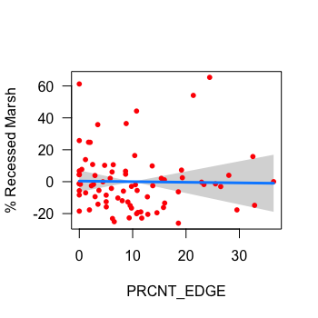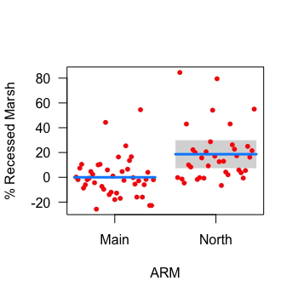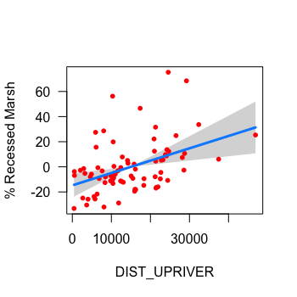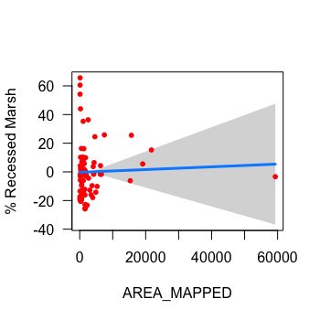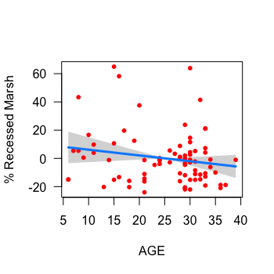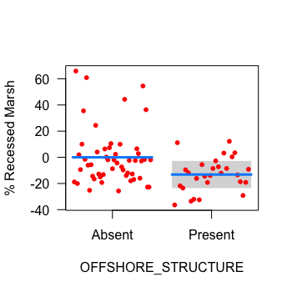

Figure C1. Plots displaying how the expected dependent variable (% mudflat) changes as a function of each model predictor (x-axis), while all other model variables are held fixed. The expected value is displayed with the blue line, 95% confidence interval for the expected value with the grey band, and partial residuals with red dots (bottom right exempt). This and all subsequent plots in Appendices C-F were created using visreg package in R (visreg, ‘visreg’ package; Breheny & Burchett 2017)

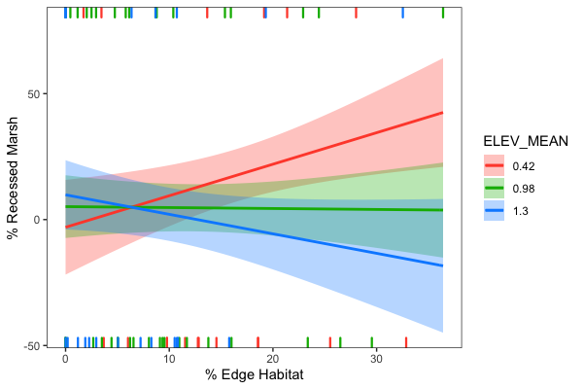

Figure C2. Cross sectional plot displaying the fit of a model with an interaction between % edge habitat and elevation on % recessed marsh. Continuous elevation data are placed into one of three cross-sections: 10th percentile (red), 50th percentile (green), and 90th percentile (blue). The expected value is displayed by regression lines, surrounded by 95% confidence intervals. Positive and negative residuals are located on the top and bottom axes.

# Appendix D. Relative % Cover Model Visualizations

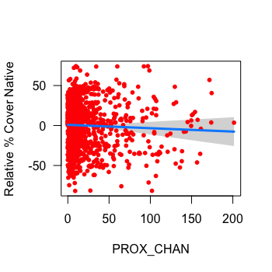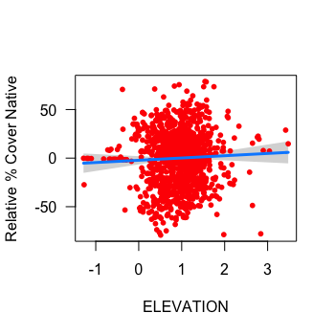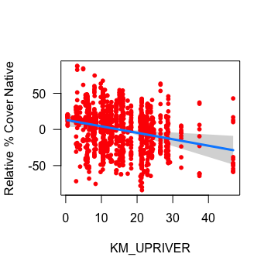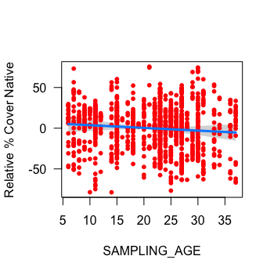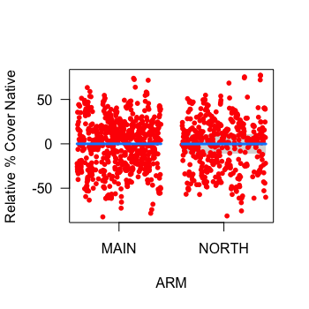

Figure D1. Plots displaying how relative % cover of native species changes as a function of each model predictor (x-axis), while all other model variables are held fixed. The expected value is displayed with the blue line, 95% confidence interval for the expected value with the grey band, and partial residuals with red dots (bottom right exempt).

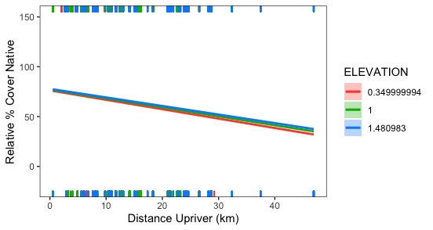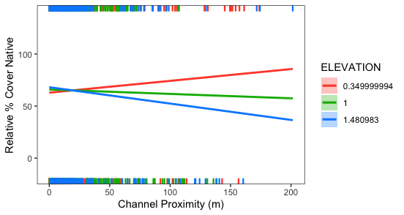

Figure D2. Cross sectional plots displaying the fit of a model with an interaction between % distance upriver and elevation (top) and channel proximity and elevation (bottom) on relative % cover of native species in sample plots. Continuous elevation data are placed into one of three cross-sections: 10th percentile (red), 50th percentile (green), and 90th percentile (blue). The expected value is displayed by regression lines, surrounded by 95% confidence intervals. Positive and negative residuals are located on the top and bottom axes.

# Appendix E. Native Richness Model Visualizations

# Chart, scatter chart Description automatically generatedAppendix F. Non-Native Richness Model Visualizations

Figure E1. Plots displaying how native richness changes as a function of each model predictor (x-axis), while all other model variables are held fixed. The expected value is displayed with the blue line, 95% confidence interval for the expected value with the grey band, and partial residuals with red dots (bottom right exempt).

Figure . Cross sectional plot displaying the fit of a model with an interaction between % distance upriver and elevation. Continuous elevation data are placed into one of three cross-sections: 10th percentile (red), 50th percentile (green), and 90th percentile (blue). The expected value is displayed by regression lines. Positive and negative residuals are located on the top and bottom axes.

Figure F2. Cross sectional plot displaying the fit of a model with an interaction between % distance upriver and elevation. Continuous elevation data are placed into one of three cross-sections: 10th percentile (red), 50th percentile (green), and 90th percentile (blue). The expected value is displayed by regression lines. Positive and negative residuals are located on the top and bottom axes.

Figure F1. Plots displaying how non-native richness changes as a function of each model predictor (x-axis), while all other model variables are held fixed. The expected value is displayed with the blue line, 95% confidence interval for the expected value with the grey band, and partial residuals with red dots (bottom right exempt).

# Appendix G. Vegetation Survey Plant List

Table G1. A complete list of macrophytes observed during 2015 and 2021 vegetation surveys with accompanying origin status (N = Native, E = Exotic, I = Invasive). For cryptic species where origin could not be determined, origin status is ‘U’.

|  |  |  |  |  |
| --- | --- | --- | --- | --- |
| **Species** | **Common Name** | **Origin** | **2015** | **2021** |
| *Achillea millefolium* | yarrow | N |  | X |
| *Agrostis capillaris* | colonial bentgrass | E | X | X |
| *Agrostis gigantea* | redtop | E | X | X |
| *Agrostis stolonifera* | creeping bentgrass | E | X | X |
| *Ajuga* sp. | unidentified ajuga | E | X |  |
| *Alisma lanceolatum* | lance-leaf water-plantain | E |  | X |
| *Alisma triviale* | water plantain | N |  | X |
| *Alisma* sp. | unidentified water plantain | U | X |  |
| *Artemesia vulgaris* | mugwort | E | X |  |
| *Athyrium filix-femina* | lady fern | N | X | X |
| *Atriplex prostrata* | creeping salt bush | E |  | X |
| *Betula pendula* | European birch | E |  | X |
| *Bidens cernua* | nodding beggarticks | N | X | X |
| *Bidens connata* | purplestem beggarticks | E | X |  |
| *Bidens tripartita* | three-parted beggarticks | E | X |  |
| *Bolboschoenus maritimus* | sea coast bulrush | N |  | X |
| *Calamagrostis canadensis* | bluejoint | N | X | X |
| *Callitriche heterophylla* | diverse-leaved water-starwort | N | X |  |
| *Callitriche hermaphroditica* | northern starwort | N | X |  |
| *Callitriche stagnalis* | water starwort | E | X | X |
| *Caltha palustris* | marsh marigold | N | X | X |
| *Calystegia sepium* | morning-glory | I |  | X |
| *Cardamine oligosperma* | little western bitter-cress | N | X |  |
| *Cardamine* sp. | bitter-cress | U | X | X |
| *Carex aquatilis* var*. dives* | Sitka sedge | N | X | X |
| *Carex cusickii* | Cusick's sedge | N | X | X |
| *Carex exsiccata* | inflated sedge | N | X |  |
| *Carex lyngbyei* | Lyngbye's sedge | N | X | X |
| *Carex obnupta* | slough sedge | N | X | X |
| *Carex scoparia* | pointed broom sedge | N | X |  |
| *Carex stipata* | prickly sedge | N | X | X |
| *Carex utriculata* | beaked sedge | N | X | X |
| *Ceratophyllum echinatum* | hornwort | N | X |  |
| *Chenopodium album* | lamb's quarters | E | X |  |
| *Clematis vitalba* | traveler's joy | I | X |  |
| *Cicuta douglasii* | western water hemlock | N | X | X |
| *Cirsium arvense* | Canada thistle | E | X | X |
| *Comarum palustre* | marsh cinquefoil | N | X | X |
| *Conzya canadensis* | horseweed | N | X |  |
| *Cotula coronopifolia* | brass buttons | E |  | X |
| *Crassula aquatica* | pigmy-weed | N | X | X |
| *Crepis tectorum* | annual hawksbeard | E | X |  |
| *Dactylis glomerata* | orchard-grass | E | X |  |
| *Daucus carota* | wild carrot | E | X |  |
| *Deschampsia cespitosa*ssp.*bringensis* | tufted hairgrass | N |  | X |
| *Distichlis spicata* | salt grass | N |  | X |
| *Echinochloa crus-galli* | large barnyard grass | E | X |  |
| *Eleocharis obtusa* | blunt spike-rush | N | X | X |
| *Eleocharis palustris* | creeping spike-rush | N | X | X |
| *Eleocharis parvula* | small spike-rush | N | X | X |
| *Elodea canadensis* | Canadian waterweed | N | X | X |
| *Elymus repens* | quackgrass | E |  | X |
| *Epilobium cilatum* | purple willowherb | N | X | X |
| *Equisetum arvense* | common horsetail | N | X | X |
| **Species** | **Common Name** | **Origin** | **2015** | **2021** |
| *Equisetum fluviatile* | swamp horsetail | N | X | X |
| *Erythranthe scouleri* | Columbia River monkey-flower | N | X |  |
| *Festuca occidentalis* | western fescue | N | X |  |
| *Festuca rubra* | red fescue | U | X |  |
| *Festuca* sp. | unidentified fescue | U | X |  |
| *Galium palustre* | marsh bedstraw | N |  | X |
| *Galium trifidum* | small bedstraw | N | X | X |
| *Geum macrophyllum* | large-leaved avens | N | X |  |
| *Glyceria elata* | tall mannagrass | N | X |  |
| *Glyceria leptostachya* | slender spiked mannagrass | N |  | X |
| *Glyceria*sp. | mannagrass | N |  | X |
| *Gnaphalium uliginosum* | marsh cudweed | E | X |  |
| *Gratiola ebracteata* | bractless hedge-hyssop | N | X | X |
| *Hieracium lachenalii* | European hawkweed | E | X |  |
| *Hordeum brachyantherum* | meadow barley | N |  | X |
| *Hypericum anagalloides* | bog St. John’s wort | N | X |  |
| *Hypericum scouleri* ssp. *scouleri* | western St. John’s wort | N | X |  |
| *Hypochaeris radicata* | hairy cat’s-ear | E | X |  |
| *Impatiens capensis* | jewelweed | E | X | X |
| *Impatiens glandulifera* | policemen's helmet | I |  | X |
| *Impatiens parviflora* | small touch-me-not | E |  | X |
| *Iris pseudacorus* | yellow-flag iris | I | X | X |
| *Isoetes echinospora* | bristle-like quillwort | N |  | X |
| *Isolepis cernua* | low clubrush | N | X |  |
| *Juncus articulatus* | jointed rush | N | X | X |
| *Juncus balticus* | Baltic rush | N | X | X |
| *Juncus bolanderi* | Bolander’s rush | N | X |  |
| *Juncus effusus* | common rush | N | X | X |
| *Juncus gerardii* | salt-marsh rush | E |  | X |
| *Juncus oxymeris* | pointed rush | N | X | X |
| *Juncus supiniformis* | spreading rush | N | X |  |
| *Juncus tenuis* | slender rush | N | X | X |
| *Lactua serriola* | prickly lettuce | E | X |  |
| *Lapsana communis* | nipplewort | E | X |  |
| *Lathyrus palustris* | marsh pea | N | X | X |
| *Leersia oryzoides* | rice cutgrass | N |  | X |
| *Lemna sp.* | duckweed | N |  | X |
| *Leymus mollis* | dunegrass | N |  | X |
| *Lilaeopsis occidentalis* | western lilaeopsis | N | X | X |
| *Limosella aquatica* | water mudwort | N | X | X |
| *Lolium perenne* | perennial ryegrass | E | X |  |
| *Lotus corniculatus* | common bird's-foot trefoil | E | X | X |
| *Lotus pedunculatus* | stalked bird’s-foot trefoil | E | X |  |
| *Ludwigia palustris* | water purslane | N | X | X |
| *Lycopus americanus* | American bugleweed | N | X |  |
| *Lycopus europaeus* | European horehound | E |  | X |
| *Lycopus* sp. | horehound | U | X |  |
| *Lysichiton americanus* | skunk cabbage | N | X | X |
| *Lysimachia maritima* | sea milkwort | N | X |  |
| *Lysimachia nummularia* | creeping jenny | E | X | X |
| *Lysimachia terrestris* | bog loosestrife | E | X | X |
| *Lysimacia thyrsiflora* | tufted loosestrife | N | X | X |
| *Lysimachia vulgaris* | yellow loosestrife | E |  | X |
| *Lythrum salicaria* | purple loosestrife | I | X | X |
| *Lythrum portula* | European water-purslane | E | X |  |
| *Melilotus alba* | white sweet-clover | E | X |  |
| *Mentha aquatica* | water mint | E | X | X |
| *Mentha canadensis* | field mint | N | X | X |
| *Mentha* x*piperata* | peppermint | E |  | X |
| *Mentha spicata* | spearmint | E |  | X |
| **Species** | **Common Name** | **Origin** | **2015** | **2021** |
| *Menyanthes trifoliata* | buckbean | N | X | X |
| *Mimulus gutattus* | yellow monkey-flower | N |  | X |
| *Bryophyta* | unidentified moss | U |  | X |
| *Myosotis scorpioides* | European forget-me-not | E | X | X |
| *Myrica gale* | sweet gale | N |  | X |
| *Myriophyllum hippuroides* | western water-milfoil | N |  | X |
| *Myriophyllum ussuriense* | Ussurian water-milfoil | N | X |  |
| *Najas flexilis* | wavy water nymph | N | X |  |
| *Nasturtium officinale* | common watercress | E | X |  |
| *Oenanthe sarmentosa* | water parsley | N | X | X |
| *Oxalis corniculata* | yellow oxalis | E | X |  |
| *Persicaria hydropiper* | marshpepper smartweed | E | X |  |
| *Persicaria hydropiperoides* | water-pepper | N | X |  |
| *Persicaria lapathifolia* | willow weed | N | X |  |
| *Persicara minor* | Asian knotweed | E | X |  |
| *Persicaria*sp. | unidentified smartweed | U | X | X |
| *Phalarus arundinacea* | reed canary grass | I | X | X |
| *Plantago lanceolata* | ribwort plantain | E | X | X |
| *Plantago major* | common plantain | E | X | X |
| *Poa annua* | annual bluegrass | E | X | X |
| *Poa pratensis* | Kentucky bluegrass | U | X | X |
| *Poa trivalis* | rough bluegrass | E | X |  |
| *Poa* sp. | bluegrass | E | X |  |
| *Poaceae* | unidentified grasses | U |  | X |
| *Polygonum aviculare* | common knotgrass | E |  | X |
| *Populus balsamifera* | black cottonwood | N | X |  |
| *Potamogeton foliosus* | leafy pondweed | N |  | X |
| *Potamogeton natans* | floating pondweed | N | X | X |
| *Potamogeton pusillus* | small pondweed | N | X |  |
| *Potentilla anserina* | silverweed | N | X | X |
| *Potentilla egedii* | coast silverweed | N | X |  |
| *Prunella vulgaris* ssp. *vulgaris* | self-heal | E | X |  |
| *Ranunculus flammula* | lesser spearwort | N | X |  |
| *Ranunculus occidentalis* | western buttercup | N |  | X |
| *Ranunculus repens* | creeping buttercup | E | X | X |
| *Ranunculus sceleratus* | celery-leaved buttercup | N |  | X |
| *Rorippa palustris* | yellow marshcress | N | X | X |
| *Rosa multiflora* | rambler rose | E | X |  |
| *Rosa nutkana* | Nootka rose | N | X |  |
| *Rubus armeniacus* | Himalayan blackberry | I | X | X |
| *Rumex conglomeratus* | clustered dock | E | X | X |
| *Rumex crispus* | curly dock | E |  | X |
| *Rumex occidentalis* | western dock | N | X | X |
| *Rumex salicifolius* | willow-leaved dock | N |  | X |
| *Sagittaria cuneata* | arum-leaved arrowhead | N | X |  |
| *Sagittaria latifolia* | wapato | N | X | X |
| *Sagina maxima* | coast pearlwort | N | X |  |
| *Sagina procumbens* | bird-eye pearlwort | E |  | X |
| *Salicornia pacifica* | pickleweed | N |  | X |
| *Salix lucida* | shining willow | N | X |  |
| *Salix sitchensis* | Sitka willow | N | X |  |
| *Salix* sp. | willow | N | X | X |
| *Schedonorus arundinacea* | tall fescue | E | X | X |
| *Schoenoplectus pungens* | three-squared bulrush | N | X | X |
| *Schoenoplectus tabernaemontani* | softstem bulrush | N | X | X |
| *Scirpus atrocinctus* | wool grass | N | X | X |
| *Scirpus microcarpus* | small-flowered bulrush | N | X | X |
| *Scutellaria lateriflora* | blue skullcap | N | X |  |
| *Sidalcea hendersonii* | Henderson's checker-mallow | N |  | X |
| *Sinapis alba* | white mustard | E | X |  |
| **Species** | **Common Name** | **Origin** | **2015** | **2021** |
| *Sium suave* | water parsnip | N | X | X |
| *Solanum dulcamara* | European bittersweet | E | X |  |
| *Solidago canadensis* | Canada goldenrod | N |  | X |
| *Sonchus arvensis* | sow thistle | E | X | X |
| *Soncus oleraceus* | common sow thistle | E | X |  |
| *Sparganium angustifolium* | narrow-leaved bur-reed | N | X |  |
| *Sparganium emersum* | emersed bur-reed | N | X | X |
| *Spergularia salina* | saltmarsh sand spurry | E |  | X |
| *Spiraea douglasii* | hardhack | N | X |  |
| *Symphiotrichum subspicatum* | Douglas' aster | N | X | X |
| *Tanacetum vulgare* | common tansy | I | X |  |
| *Taraxacum officinale* | common dandelion | E | X | X |
| *Trifolium pratense* | red clover | E | X |  |
| *Trifolium repens* | white clover | E |  | X |
| *Trifolium wormskioldii* | springbank clover | N | X |  |
| *Triglochin maritima* | sea arrowgrass | N | X | X |
| *Triglochin scilloides* | flowering quillwort | N | X | X |
| *Typha angustifolia* | narrowleaf cattail | I | X | X |
| *Typha* x *glauca* | hybrid cattail | I | X | X |
| *Typha latifolia* | broadleaf cattail | N | X | X |
| *Vicia cracca* | tufted vetch | E | X |  |
| *Veronica anagallis-aquatica* | water speedwell | E | X | X |
| *Veronica beccabunga* | American speedwell | N | X |  |
| *Veronica scutellata* | marsh speedwell | N | X | X |
| *Veronica serpyllifolia*var.*humifusa* | thyme-leaved speedwell | E | X |  |
| *Viola langsdorffii* | Alaska violet | N | X |  |
|  |  |  |  |  |

1. According to the Policy these losses could not occur in fish habitats with high productive capacity